**The rumored iPhone selfie camera development should reach all Apple devices.**

**Bring best webcams to Mac, Apple**

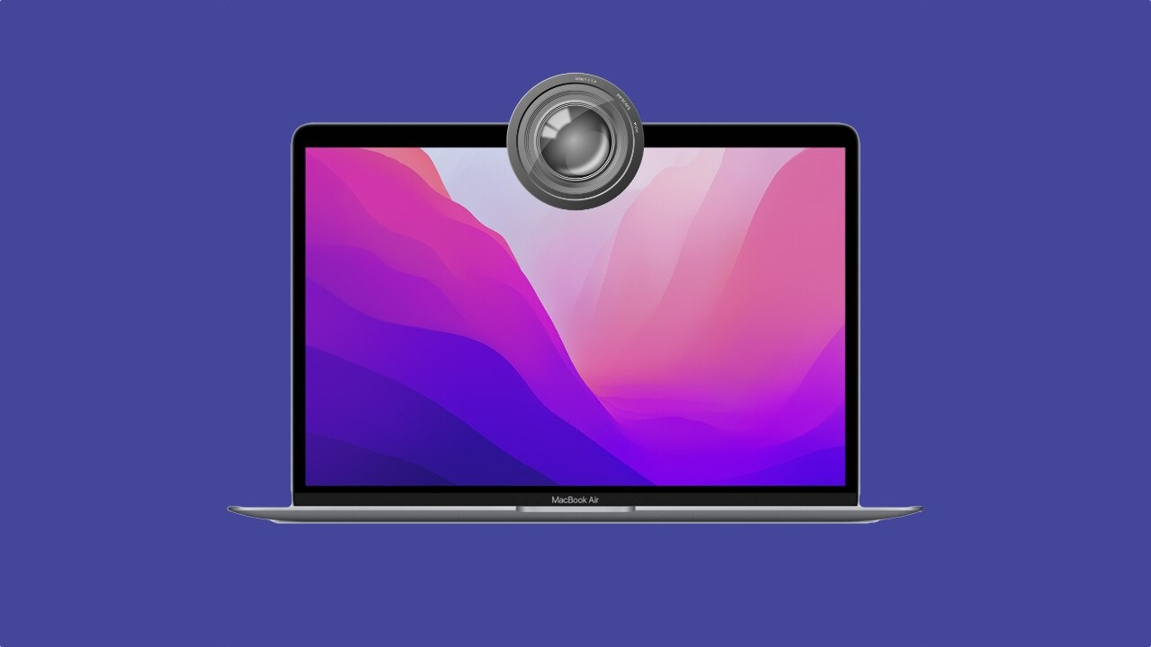

Apple is developing a selfie camera for the upcoming iPhone 14.

That is according to a report from South Korea's Electronic Times Internet store, which noted that the company has placed an order with the LG Inno for the front-end camera which is three times more expensive than the iPhone 13.

Of course, there is no guarantee that using the most expensive part of the iPhone 14 selfie camera is ethereal. But combining Apple's computer with the new hardware, we can find a winning combination.

But that is not exactly what this article is about.

Apple should focus on improving the cameras on some of its devices. And it should start with Macs.

I bought a MacBook Air with an M1 last year. While I was happy with its performance, its 720p central camera did not impress me.

Apple's MacBook Air for M1 needs a better camera.



At a time when you have to make video calls almost every day, the current Macbook camera is pathetic.

Unless you are sitting in a very bright room, you will be disturbed by the grain image on the screen.

Sure, I can ‘solve’ this problem by buying an outdoor webcam, but I don’t want the difficulty of filling up when I go to a cafe or workplace.

But it’s not just the MacBook Air. The company's new $ 1,500 Studio Display has the same problem. When the device reached reviewers in March, many of them complained about grain, washed, and uncluttered images.

Last month, Apple pushed for a noise reduction update and improved color and brightness. As The Verge noted, much of the image quality in the exhibition is related to the fact that the company opted for the use of a wide-angle camera, and later used a cropped video to stream it. It's not good.

Improving the iPhone selfie camera could be a priority for Apple as device sales account for a large sum of money on the company’s balance sheet.

But it should not forget the tons of people who buy Macs for work. I hope to see some of the announcements in this area from Apple next month at the World Engineers Conference (WWDC), where it often unveils new products and updates.